MINUTES of WP2 SESSIONS DURING KNOWLEDGE SHARING WORKSHOP
Bristol. 4-8 April 2016

Monday 4, afternoon.
Revision of FG and FG-Results from Spain.

Assistants:
WP2: Helena González, Oriol Marimon, Leanne Gunn, David Price, Paul Boniface.
WP3: Mireia Bes, Sam Pollock, Ellie Hart, Kat Wall, Fiona Hyland, Kate Miller, Jon James, Livio Riboli-Sasco, Claire Ribrault
WP4: Isabel Ruiz, Maria Heras, Erick Jensen
WP6: Casimiro Vinzini

Conclusions:
- FG improvement suggestions have been applied to FGs. See Reformulated-FG.
- FG sessions have to be recorded
- FG have to be renamed to Participatory Workshops
- Diversity group from “Consell de Cent” have to be tacked out from analysis.
- Reanalyse subcategories in FG1
- Analyse Low/Medium independently
- Analyse Spain/France/UK independently
- Include students opinions that allows us to extract conclusions

Wednesday Morning
Task 2.2 organization

Assistants:
WP2: Helena González, Oriol Marimon, Leanne Gunn, David Price, Paul Boniface.
WP3: Mireia Bes, Sam Pollock, Ellie Hart, Kat Wall, Fiona Hyland, Kate Miller, Jon James, Livio Riboli-Sasco, Claire Ribrault
WP4: Isabel Ruiz, Maria Heras
WP6: Casimiro Vinzini

Conclusions:
Participatory workshops of Task 2.2 will be implemented following next scheme:
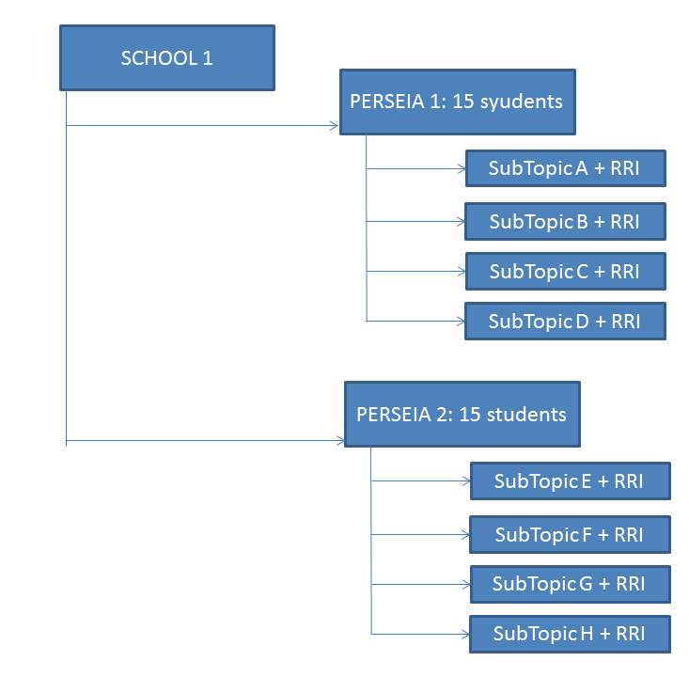

Friday 8, afternoon.
How to include RRI into PERSEIAs

Assistants:
WP2: Helena González, Oriol Marimon, Leanne Gunn, David Price, Paul Boniface, Bérénice Collet, Anissah Benchelah

Conclusions:
- Task 2.1-PERSEIAs can be delivered into 10 to 16 schools until December. In SMS case, they have to delivery before starting Participatory Workshops corresponding to Task 2.2
- Task 2.1-PERSEIAs will be delivered in a Science Festival in case of SMS
- Wendy Sadler from SMS does not be SMS-Responsible Person in UK CS any more. Will be substituted by Reachel in one month or so
- Meriem Fergusson from SMS does not be TRACES-Responsible Person in France CS any more. Will be substituted by Céline and Paul.
- SMS and TRACES will send FG-Data completed before end of May 2016
- All Task 2.1-PERSEIAs will be composed by short sketches
- Each sketch will focus, at least, one RRI topic
- All PERSEIA will have interaction with the public
- During the session, ideas and approximations were shared between the group.

