How to upload your deliverables

- Log in in the Participant Portal at:
http://ec.europa.eu/research/participants/portal/desktop/en/home.html

- Click on “My Project(s)” in the section My Area:
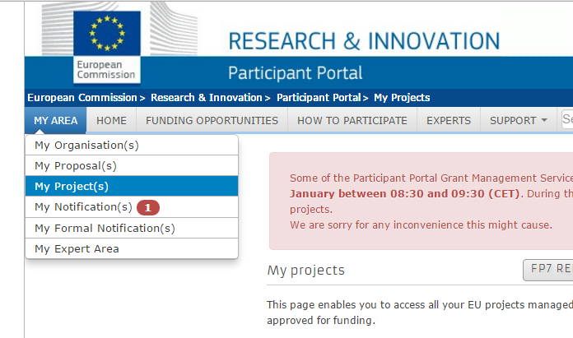

- Click on the MP button on the right of project PERFORM:
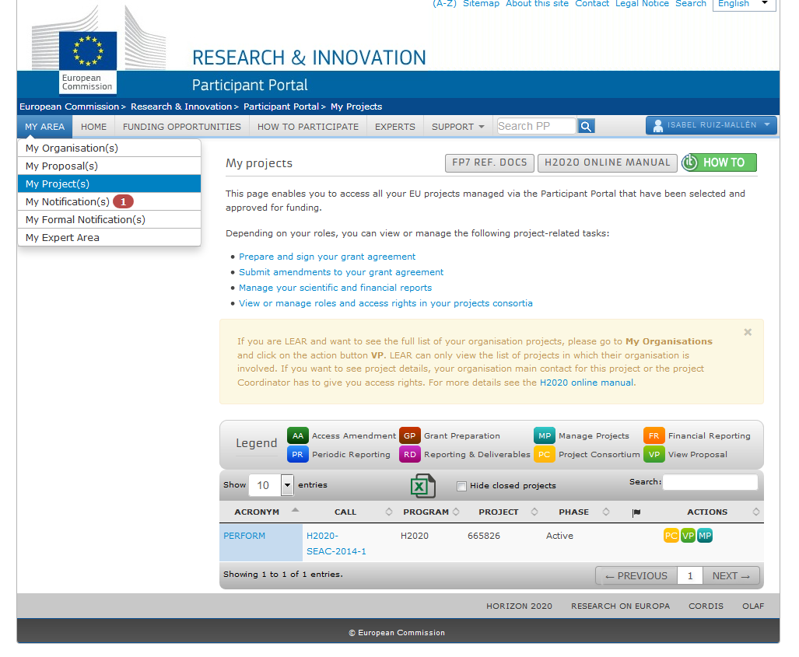

- Click on “Continuous Reporting (data)”

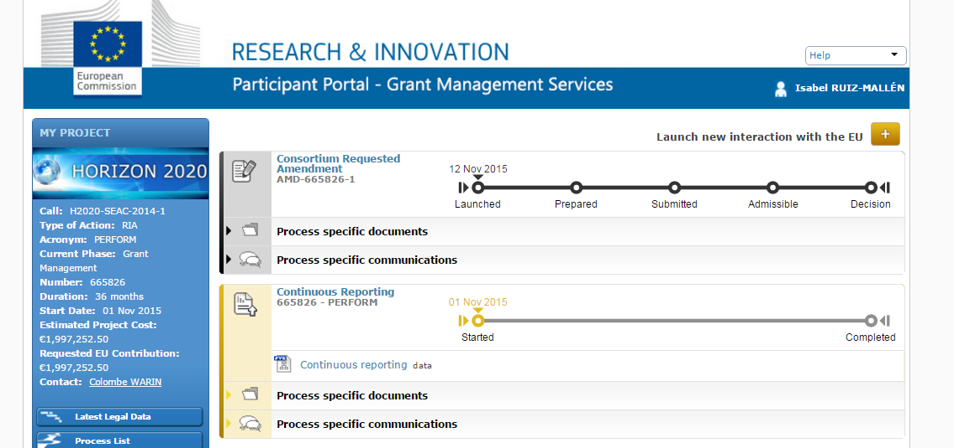

- Push on the green button on the right to upload your deliverable:

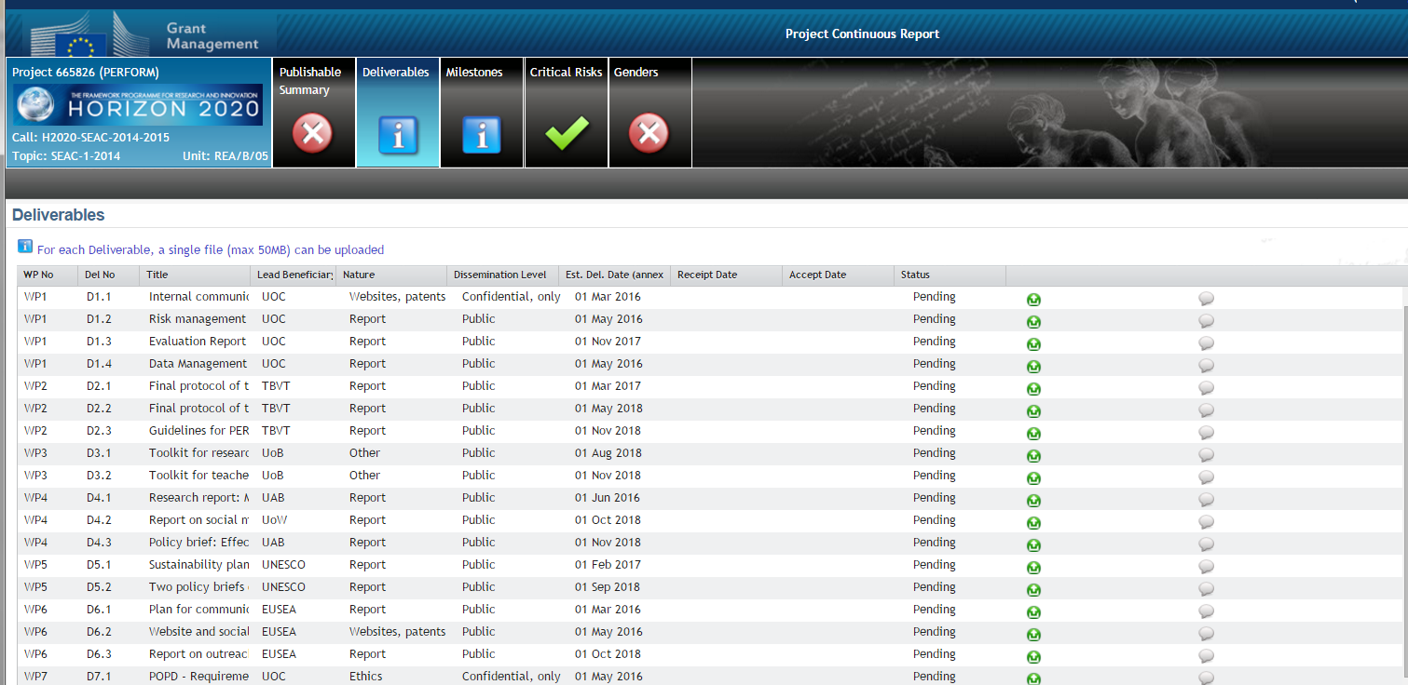

How to upload your milestones

